|  |  |
| --- | --- |
| **Full Name** | Megha Manohar Dodke |
| **Batch** | Dec 2020 |
| **Project Title** | CI/CD Deployment for Springboot Application. |
| **Project Submission Date** | 31-July – 2022 |
| **Git Hub Project Link** | git@github.com:MeghaDodke/AWS-APP-Deployment.git |

**1.Creating the new Ec2 linux instance:-**

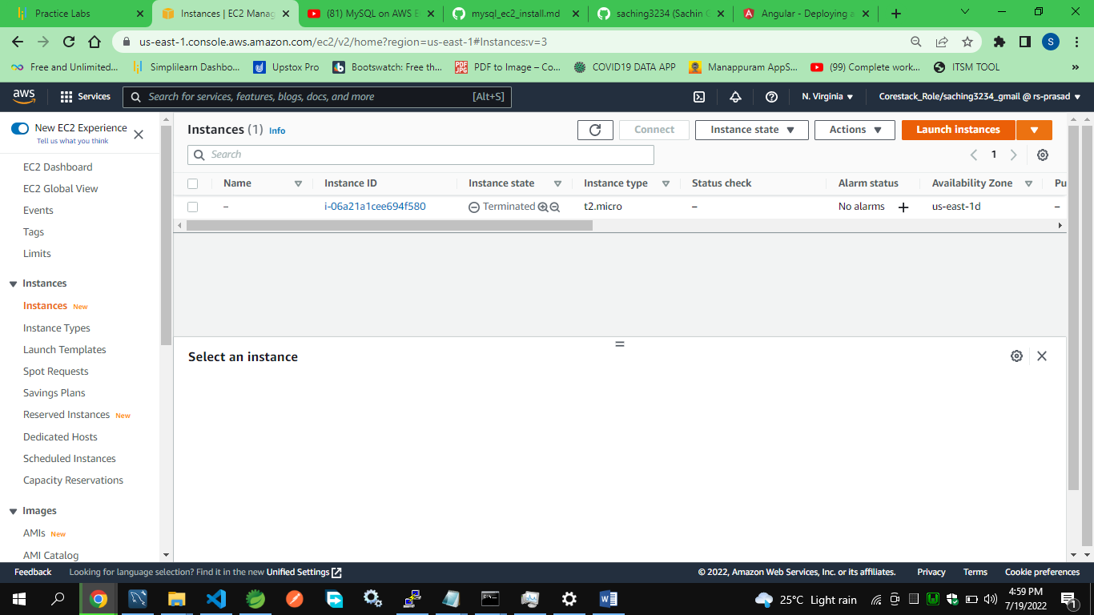

**2.selected Amazon Linux 2 AMI (HVM) - Kernel 5.10, SSD Volume Type :-**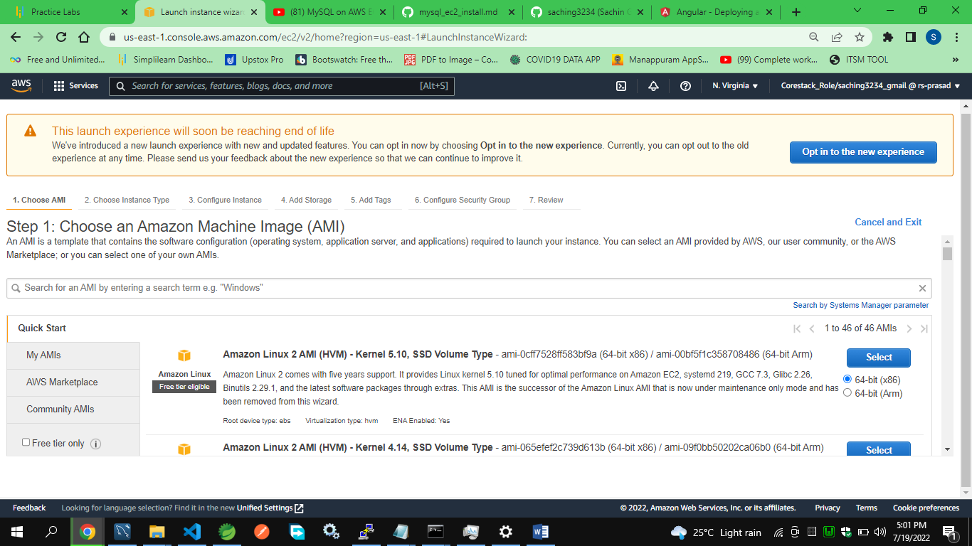

**3.selected t2.micro Free tier eligible**

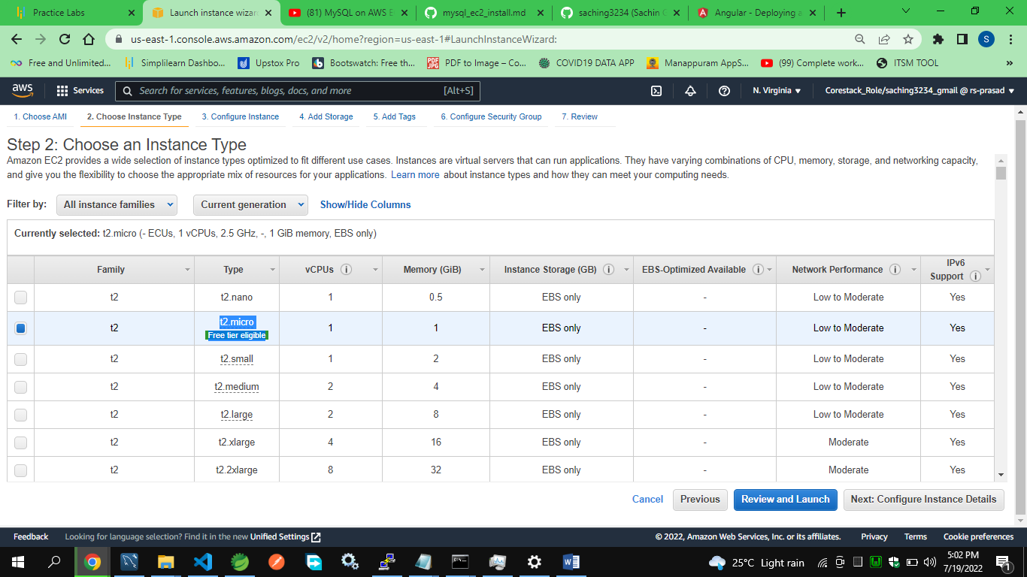

**4.** **Configure Instance Details :-**

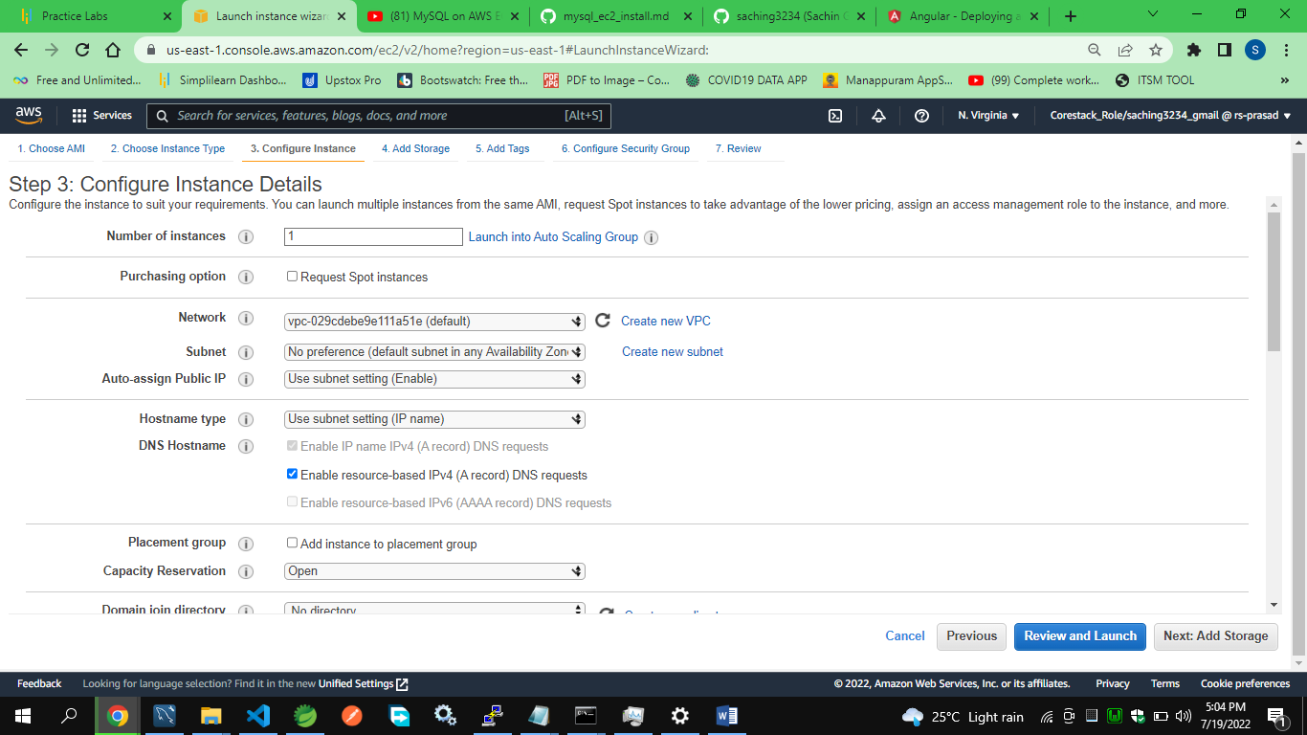

**5. Adding Storage:-**

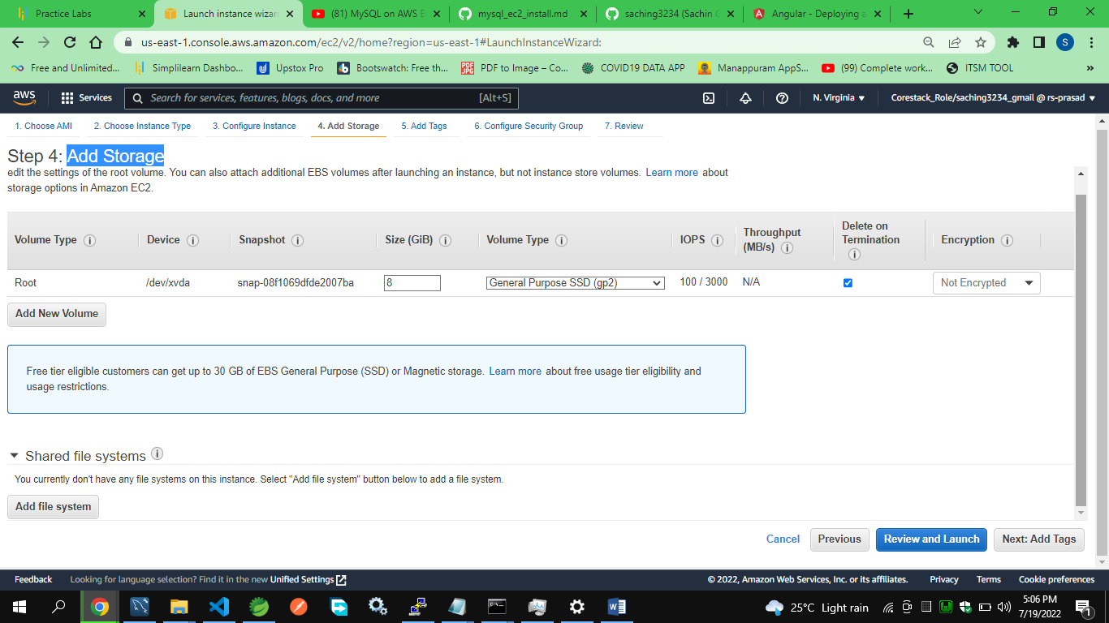

**6.** Adding Tags-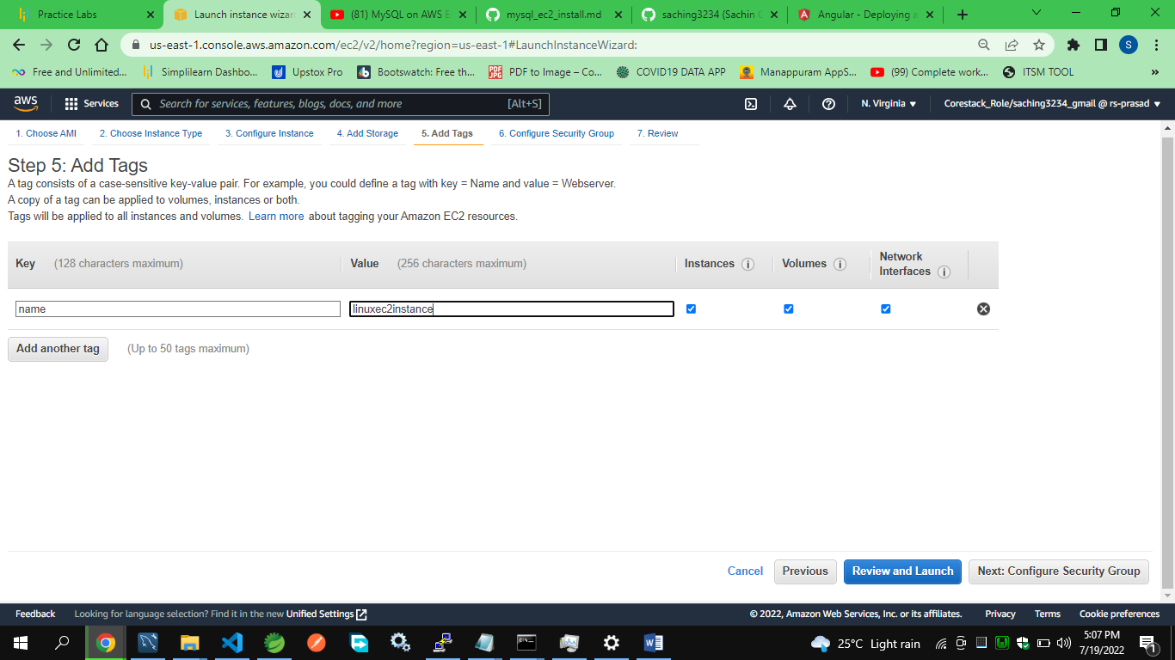

**7.Setting the firewall rules**

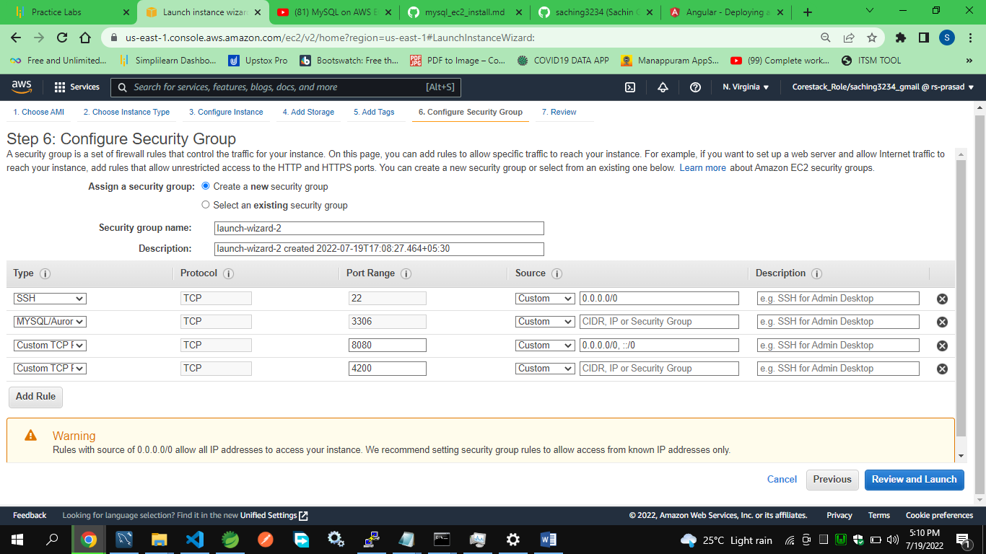

**8.Launching the instance**

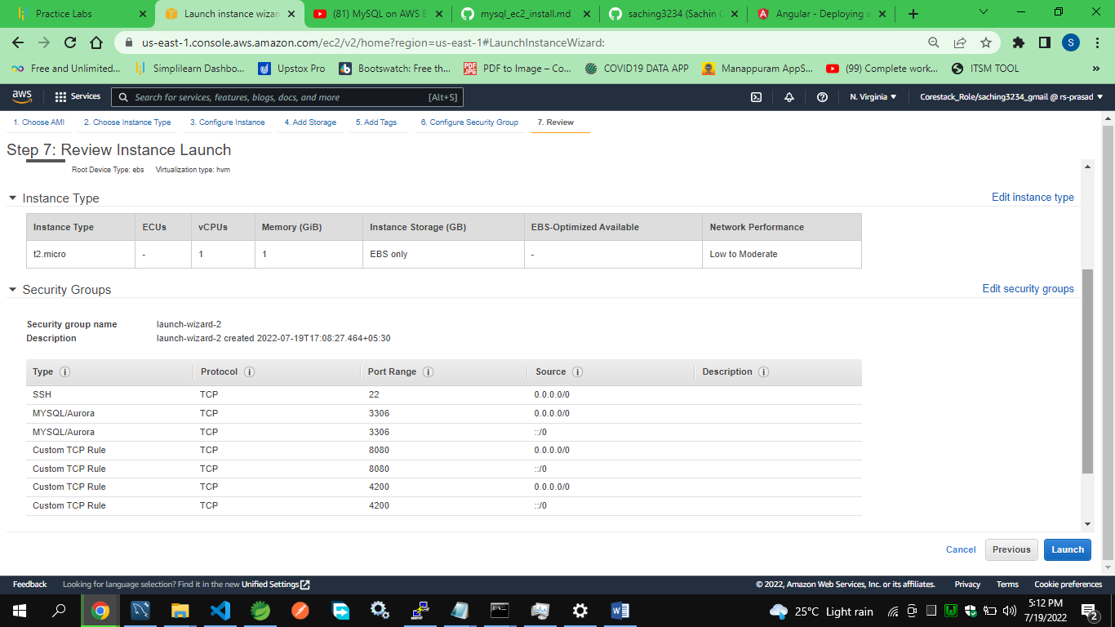

**9.Creating the key for login the instance-**

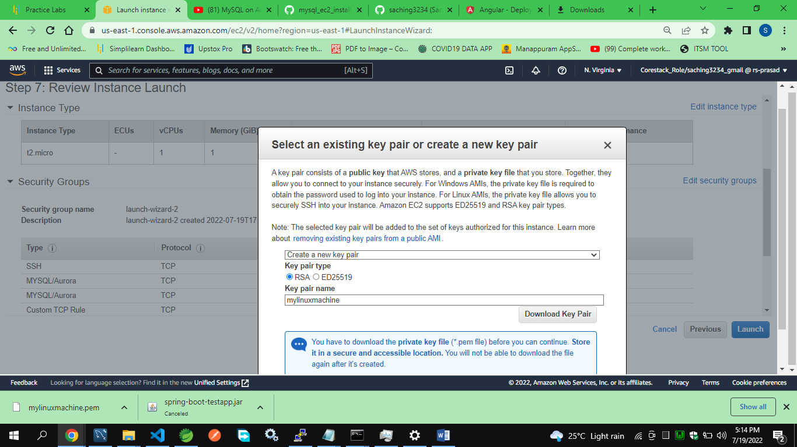

**10. Running Instance:-**

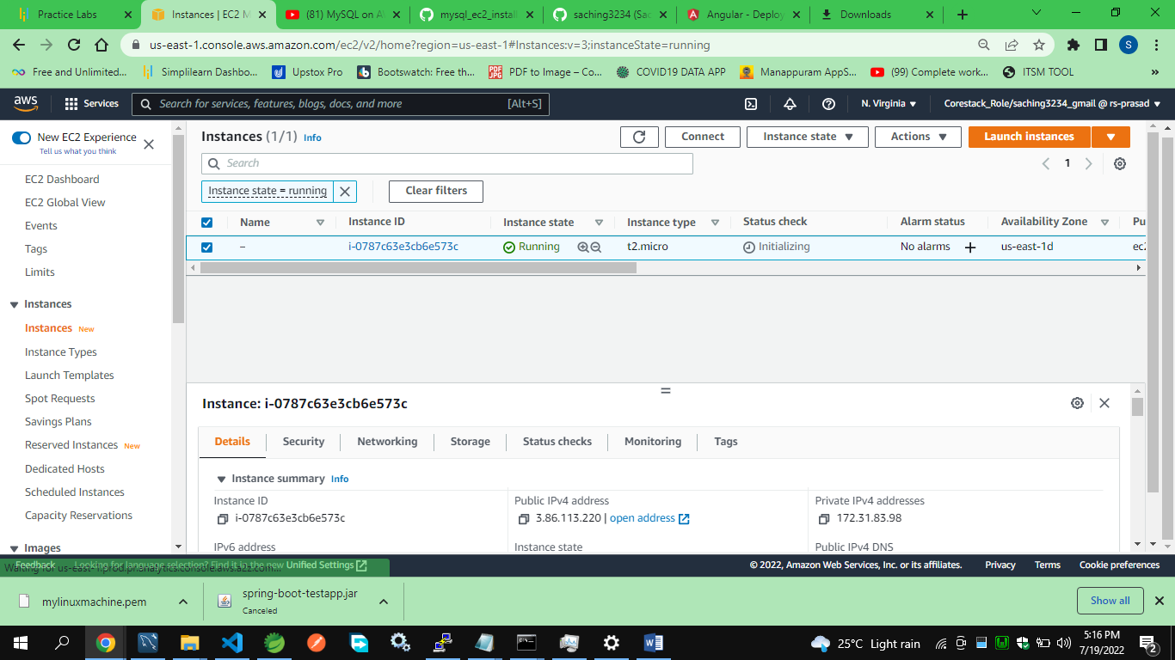

**11.Conneting to the instance**

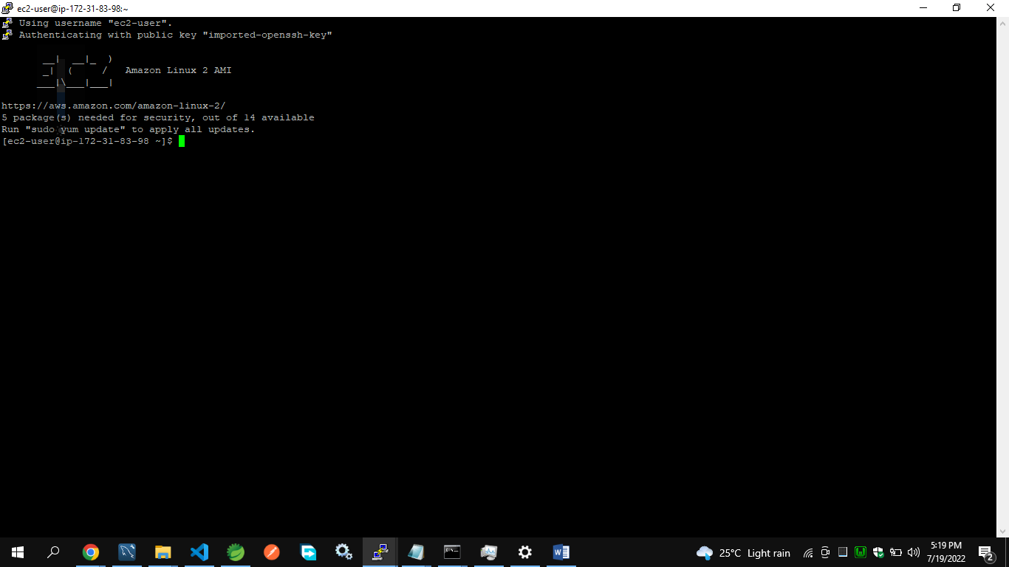

**12.Insatlling the Mysql Server-**

#mysql installation commands-

#going to root user

sudo su

sudo yum install -y https://dev.mysql.com/get/mysql80-community-release-el7-3.noarch.rpm

sudo amazon-linux-extras install epel -y

sudo yum install -y mysql-community-server

#imported GPG-KEY:

sudo rpm --import https://repo.mysql.com/RPM-GPG-KEY-mysql-2022

#Installing the mysql serversudo yum install mysql-server -y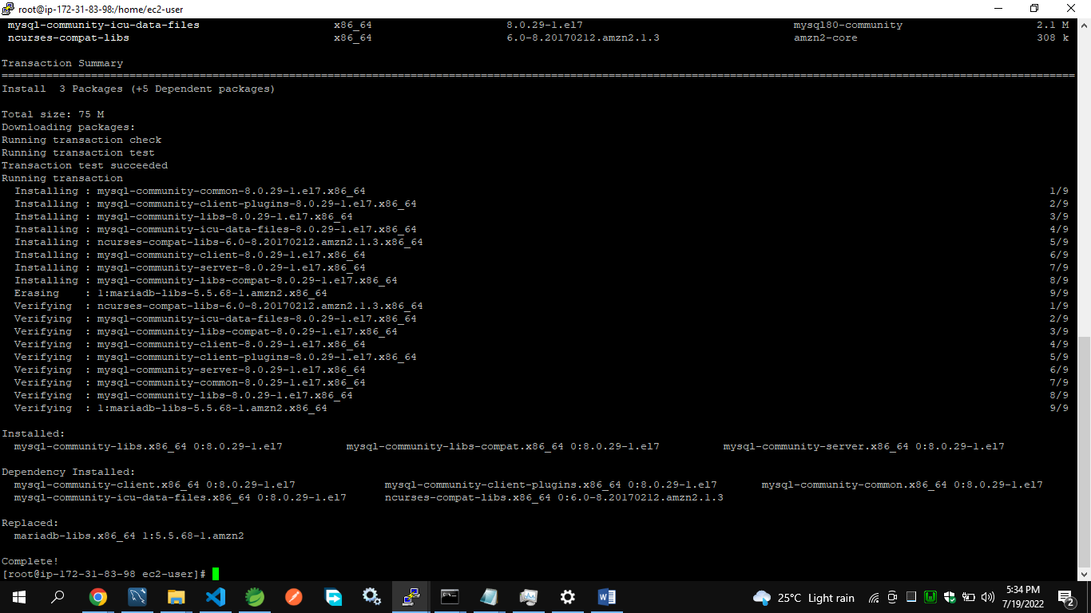

**13.Creating the new user in mysql.**

#Starting the mysql server

sudo systemctl start mysqld

sudo systemctl enable mysqld

#Get the password for the root user:

sudo grep 'temporary password' /var/log/mysqld.log

#Login to MySQL:

mysql -u root -p

#You have to change the root user's password before you can do anything

ALTER USER 'root'@'localhost' IDENTIFIED WITH mysql_native_password BY 'Sachin@20';

CREATE USER 'sachin'@'%' IDENTIFIED WITH mysql_native_password BY 'Sachin@20';

GRANT ALL PRIVILEGES ON *.* TO 'sachin'@'%';

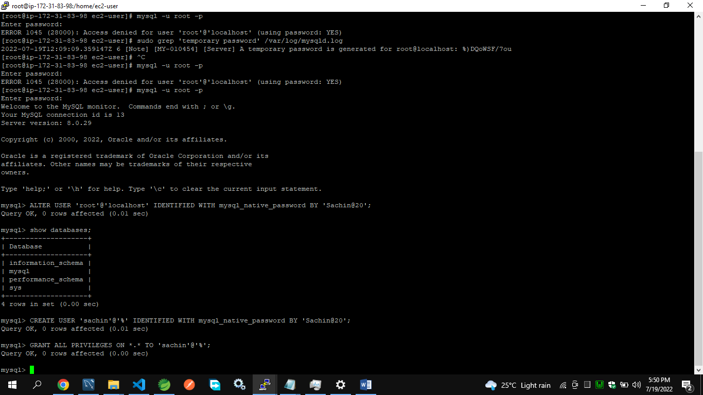

**14.Connecting to the mysql server and creating the database**

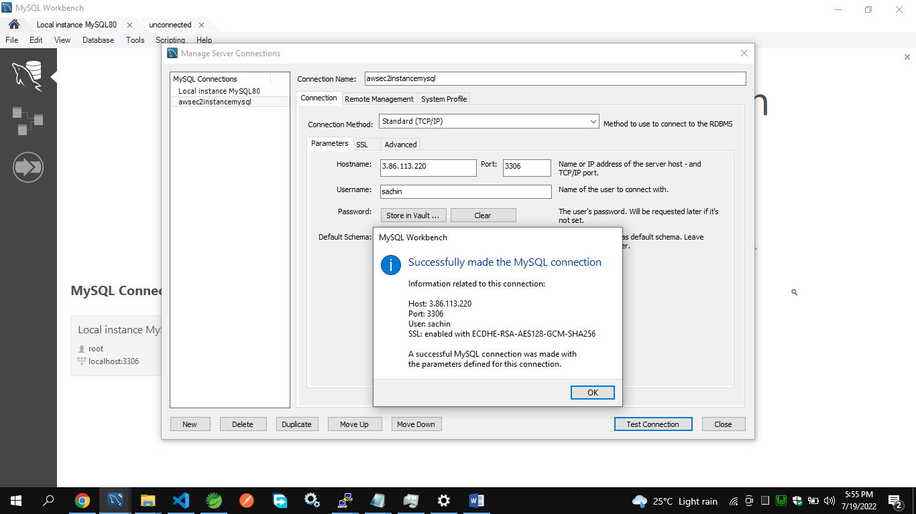

**15.Data Imported from local db to ec2 mysql server db**

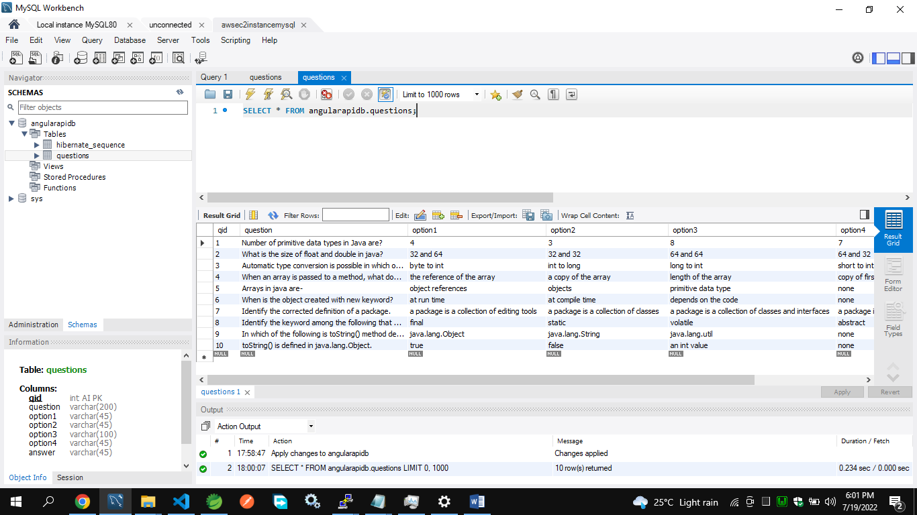

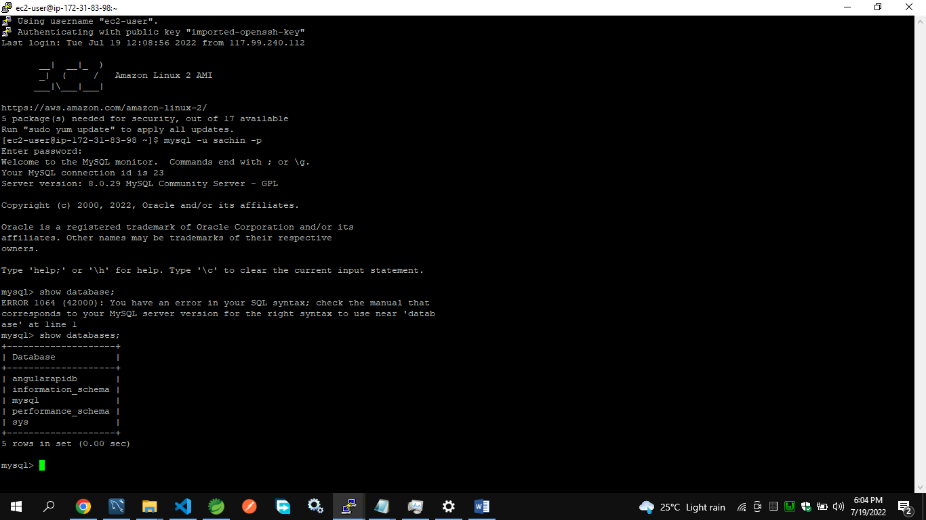

**16. Installing the java on ec2**

sudo amazon-linux-extras install java-openjdk11

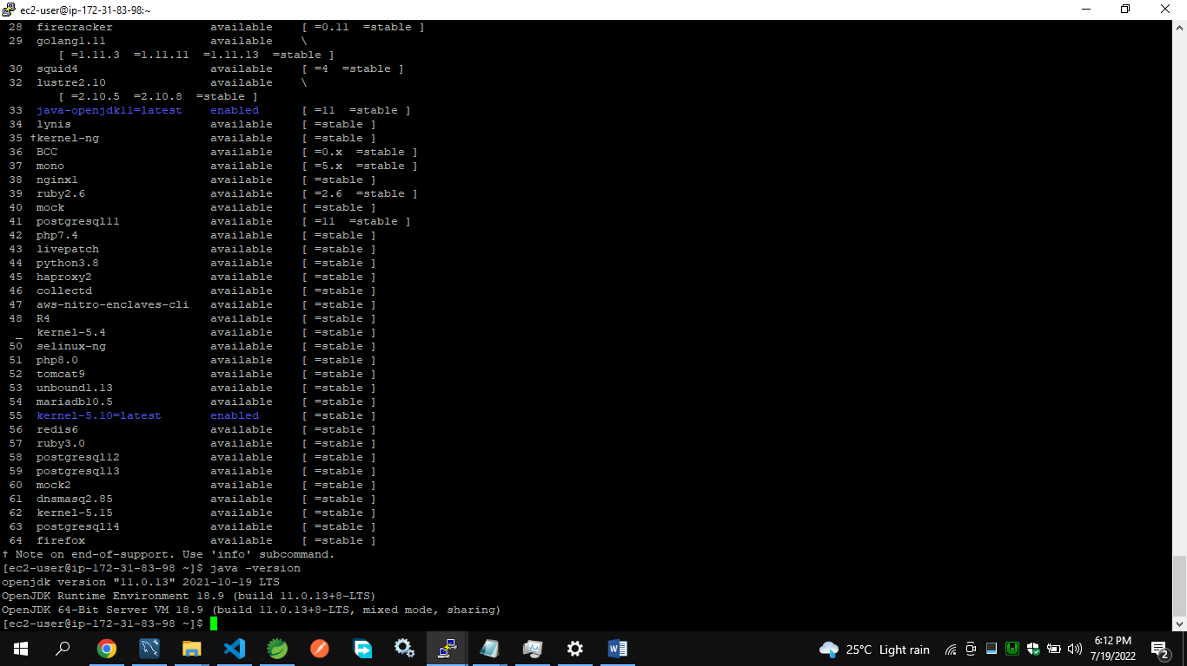

**17.Created the final build of java spring boot project**

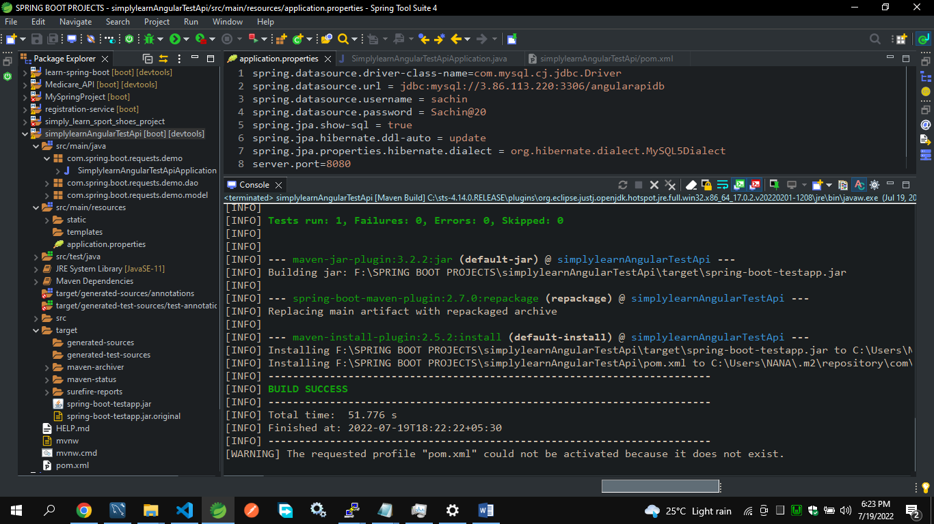

**18. Creating the S3 bucket-**

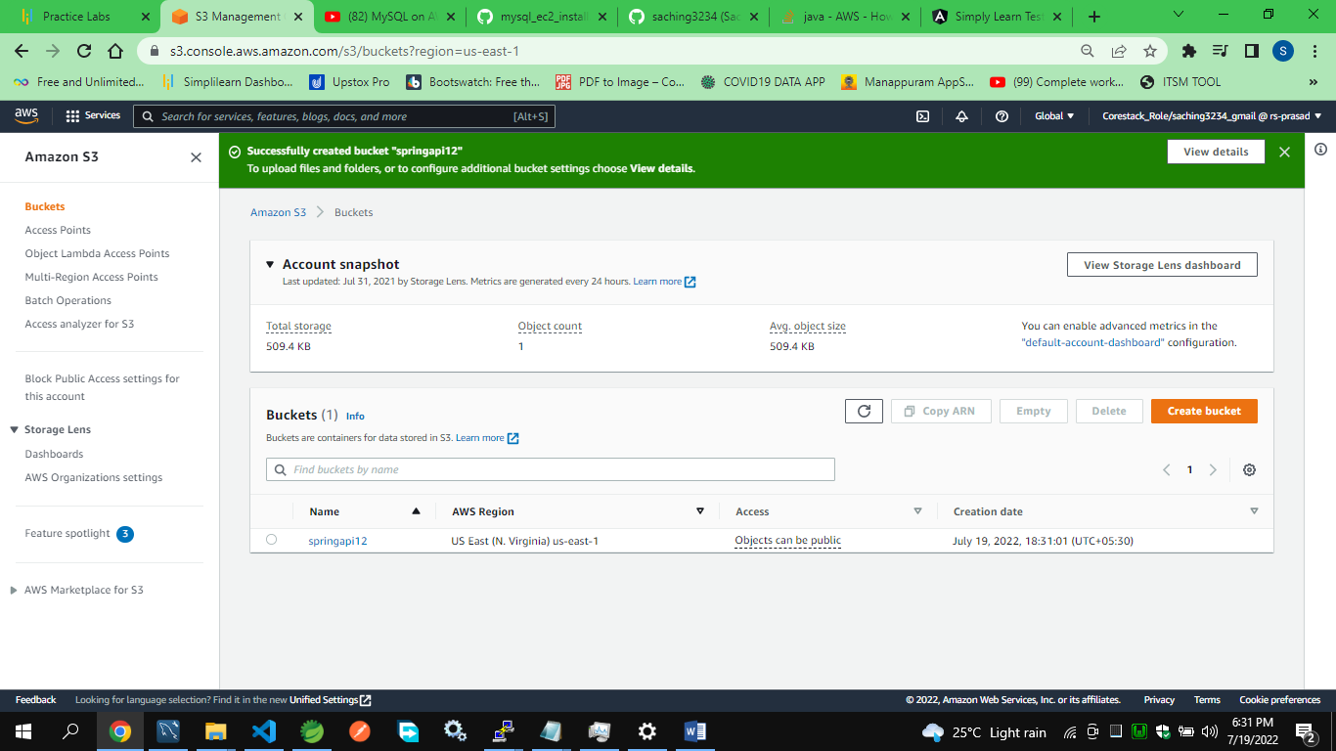

**19. Uploading the final jar into the S3 bucket**

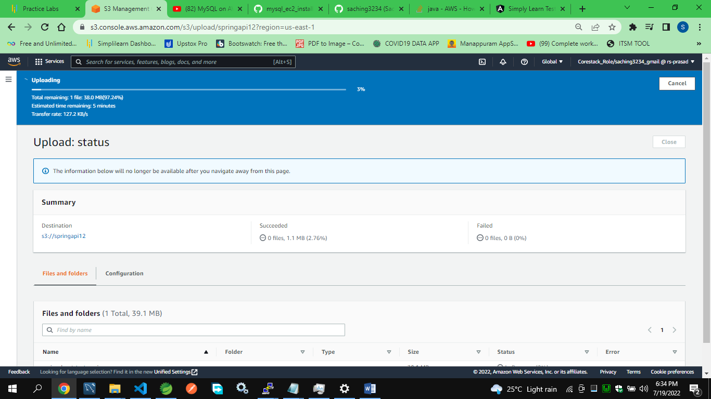

**20. Making the jar available publically**

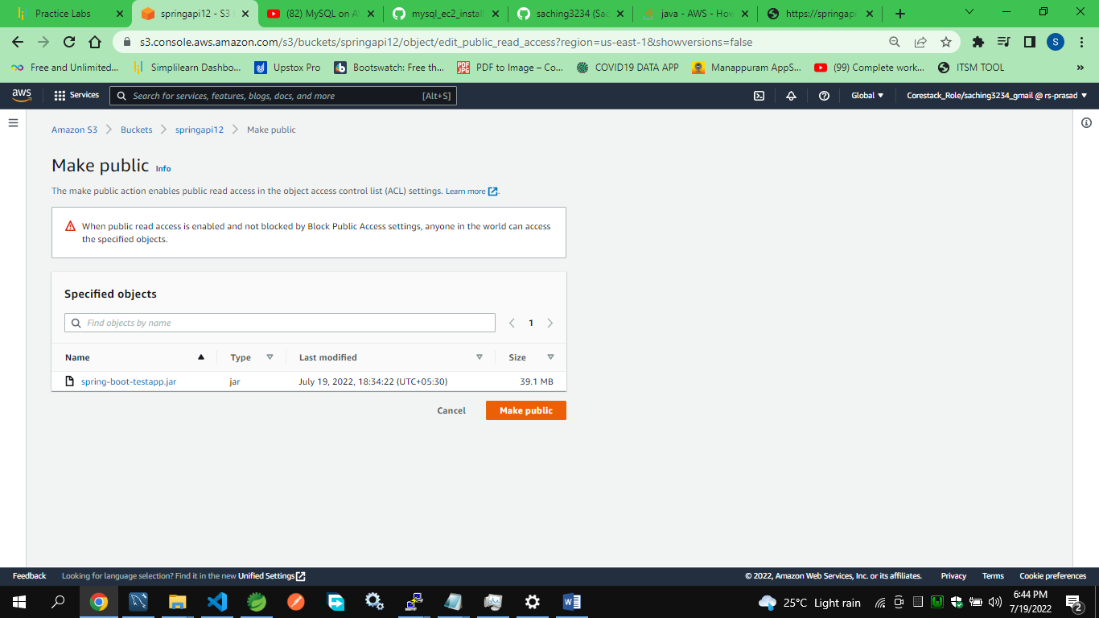

**21. Downloading the jar file in the ec2 instance**

wget https://springapi12.s3.amazonaws.com/spring-boot-testapp.jar

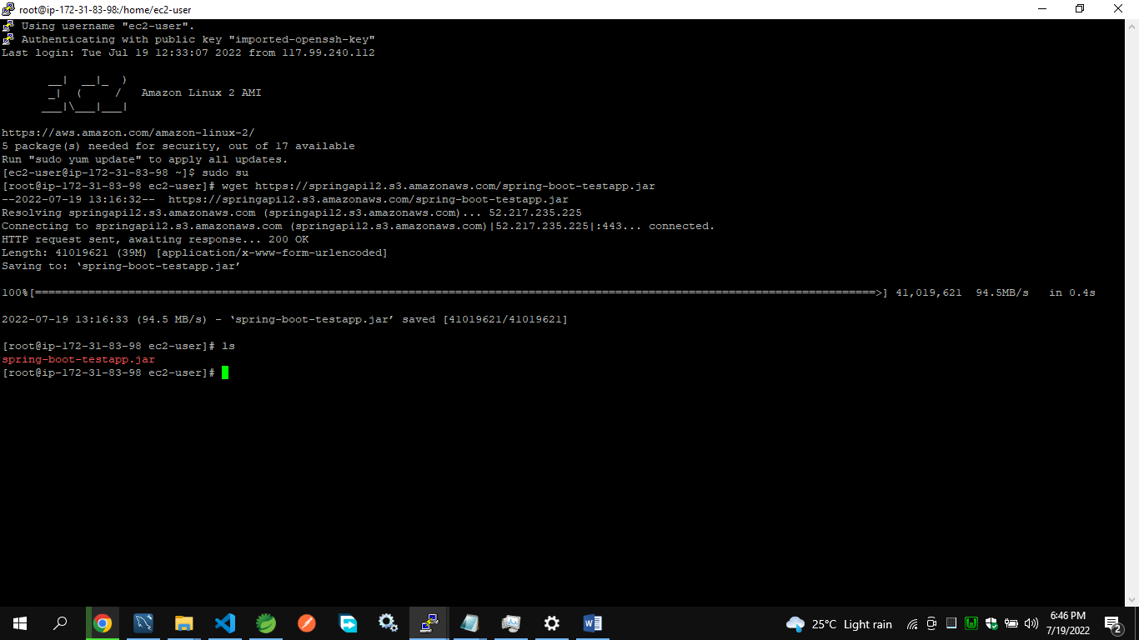

**22. Running the spring boot app-**

java -jar spring-boot-testapp.jar spring-boot-testapp.jar

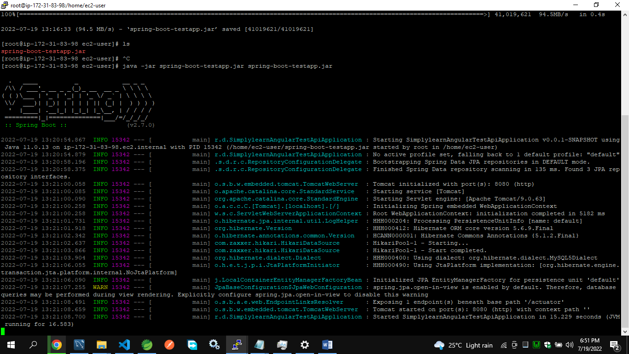

**23. Building the angular app for final deployment .**

Ng build

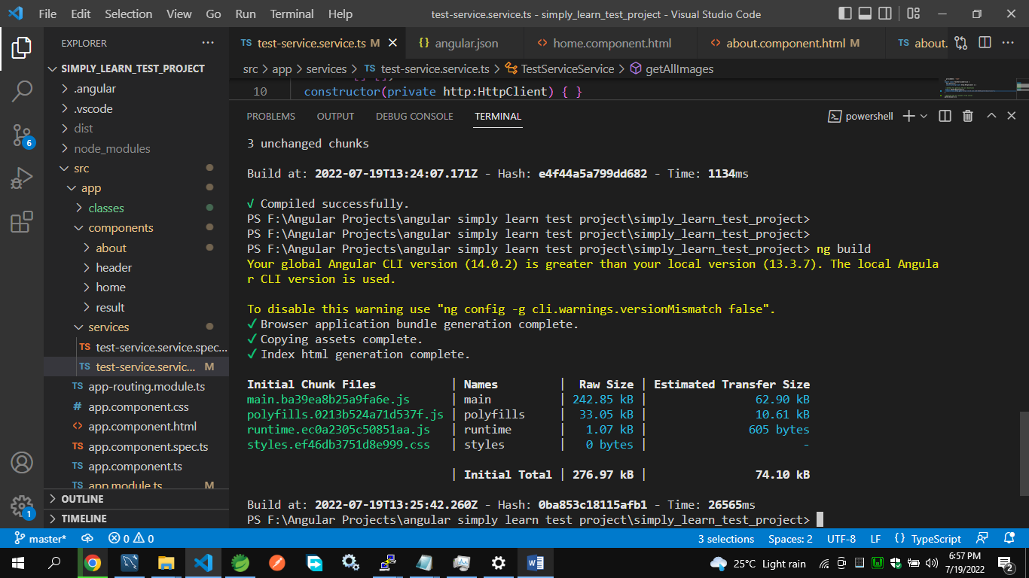

**Two s3 buckets-**

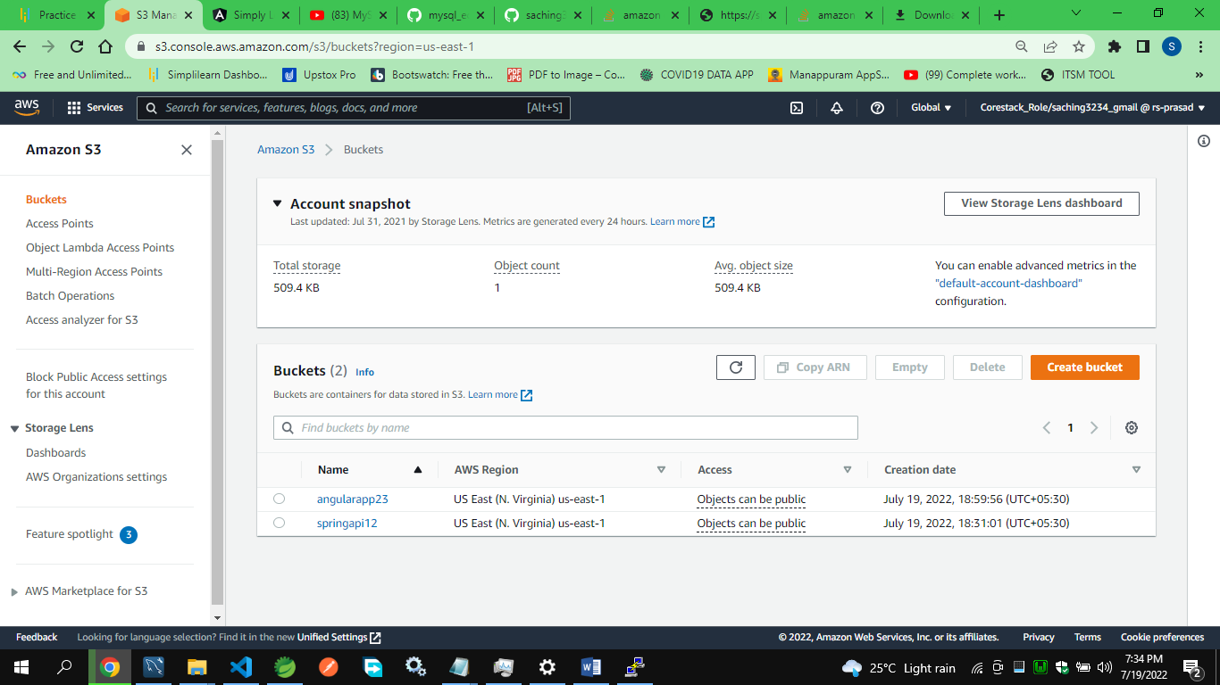

**24. Hosting the angular app on s3 bucket**

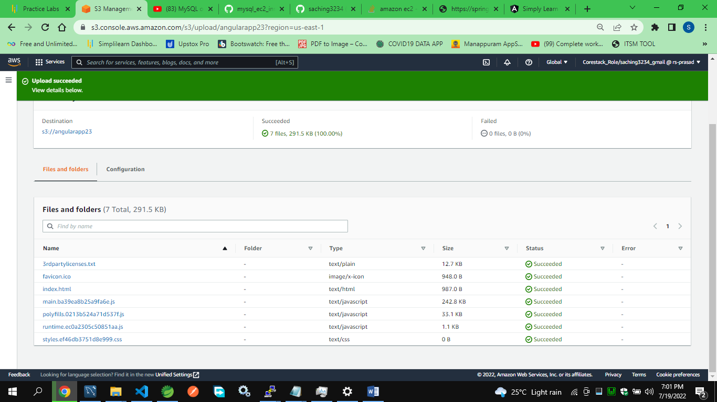

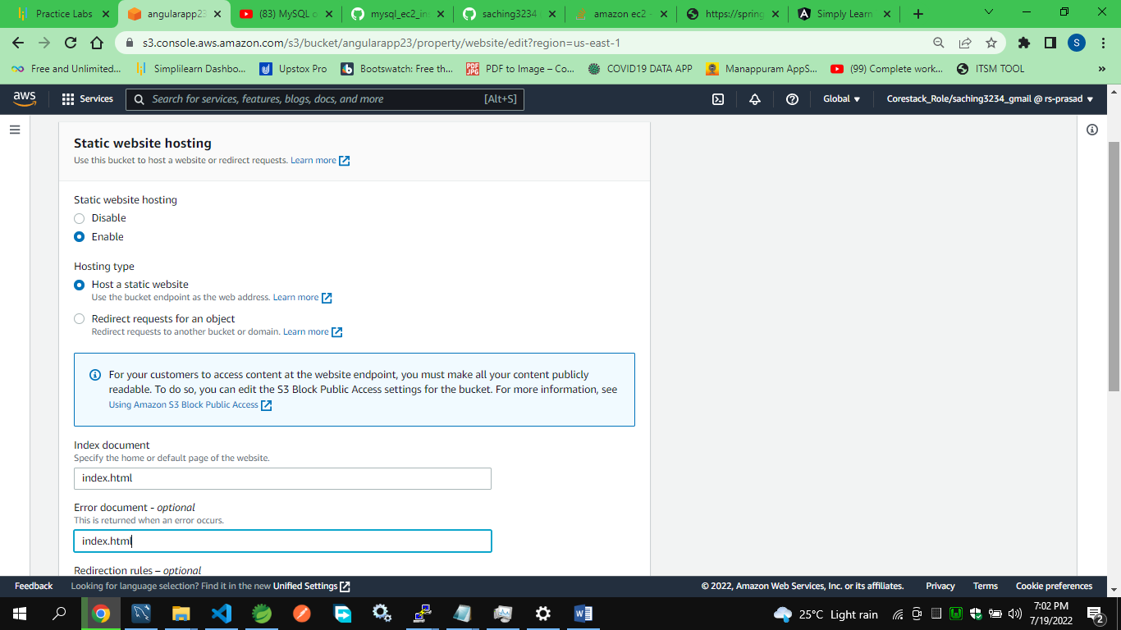

**Giving the permission to access the files publically**

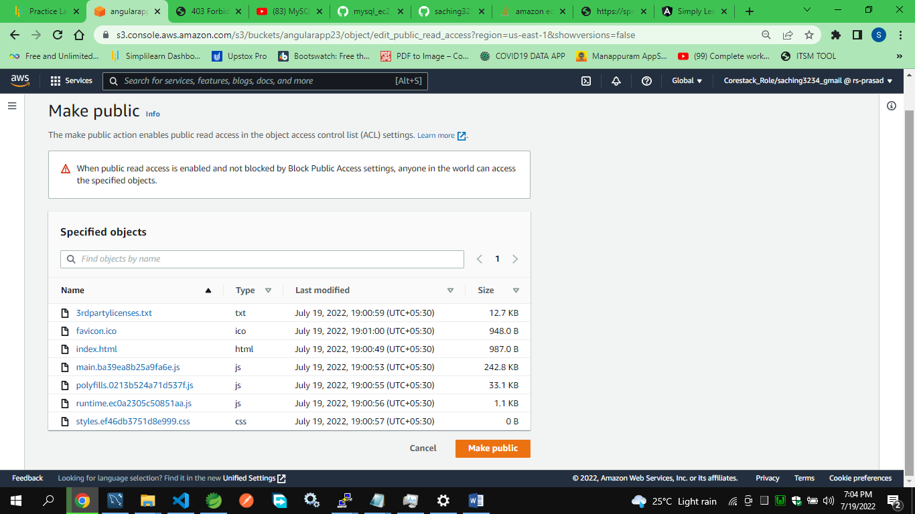

**Website accessible now**

**http://angularapp23.s3-website-us-east-1.amazonaws.com/home**

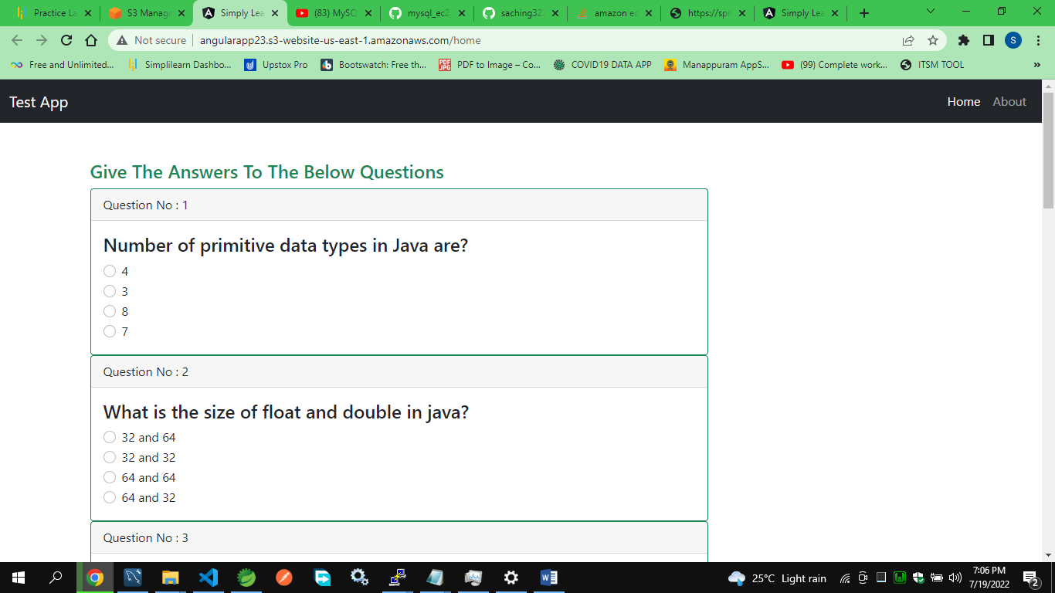

**Real Time working of backend and front end-**

